LAYNHAPUY HOMELANDS ABORIGINAL CORPORATION

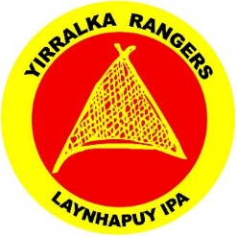
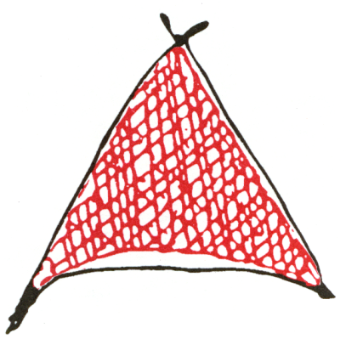
POST OFFICE BOX 1546, NHULUNBUY, NT 0881 86 Galpu Road, Yirrkala .
Telephone Email
YIRRALKA RANGERS (08) 8939-1850 ipaadmin@laynhapuy.com.au
ADMINISTRATION (08) 8939-1800 customer_service@laynhapuy.com.au
HEALTH (08) 8939-1821 health.admin@laynhapuy.com.au

ABN 86 695 642 473 ICN 7657

Administration Coordinator – Yirralka Rangers
Fixed Term Full Time role for 2 years.
Base salary range – $64,664 to $70,664 plus super and annual remote living allowance.
Are you the Administration Coordinator we’re looking for? Laynhapuy Homelands Aboriginal Corporation, identified locally as Laynha, is a well-established and reputable Aboriginal organisation based in Yirrkala on the East Coast of Arnhem Land, situated close to the township of Nhulunbuy. Laynha provides infrastructure, health, cultural and natural resource management services across the region. Our region is one of the most beautiful and vibrant areas in Australia and has excellent facilities with which to work, live and play.
What kind of person are you? You will have strong personal values such as compassion, a high level of personal integrity and a commitment to ethical behaviour. You have effective interpersonal skill and demonstrate initiative at all times and can calmly respond to situations as they arise. You understand that high level service and team work is the driver of organisational success. You are confident in your abilities, calm, self-resilient, independent thinking and have a robust sense of humour and a willingness to continually learn. You aren’t a ‘know it all’ and don’t take yourself too seriously and want to succeed working alongside like-minded people.
What will I need to succeed? Previous experience in an administration role working within the appropriate cultural context. Able to develop and maintain office systems while utilising your strong computer skills within MS Office and financial management systems. You will have excellent time-management and a customer service focus in your day to day work which will challenge your excellent communication and decision-making skill. You are excited about the prospect of your transferable skill being able to offer you a career move where you will contribute in ensuring the sustainability of a leading Aboriginal organisation. Willing to undertake study if needed and keen to be provided the opportunity to be the best you can be in your role. You can appreciate the challenges of the Not-For-Profit sector, even if you haven’t worked in it (yet).
Benefits include 6 weeks’ annual leave with 17.5% leave loading, 15 days’ personal leave, 2 days’ annual travel leave, annual remote living allowance and a commitment to professional development. You are also able to access salary sacrifice arrangements.
Interested? Talk to our HR Consultant, Linda Harpur to find out more about this opportunity to be part of our team. You can give her a call on 0467 656 533 or email her at hr.consultant@laynhapuy.com.au
If you think you are the right person for us, email a current resume with a cover page telling us about yourself to hr.consultant@laynhapuy.com.au by 5pm Friday, 27th January 2019.

